Project 3: Design Document

Rupakeerthana Vemulapalli

20778222

# What class(es) did you design? What are the member variables and member functions for each of these classes?

Classes:

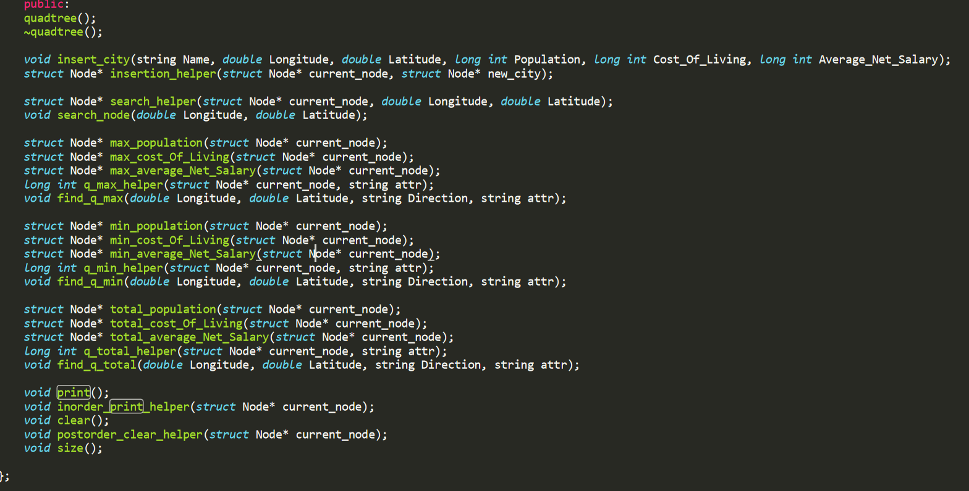

*Note: the helper functions are used in each case to implement the actual functions

Member variables:

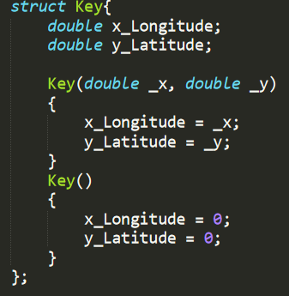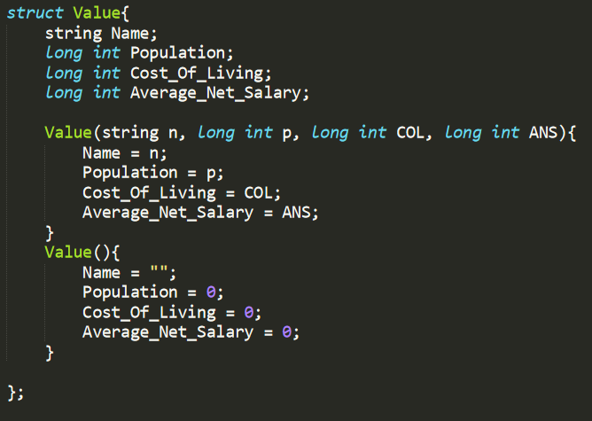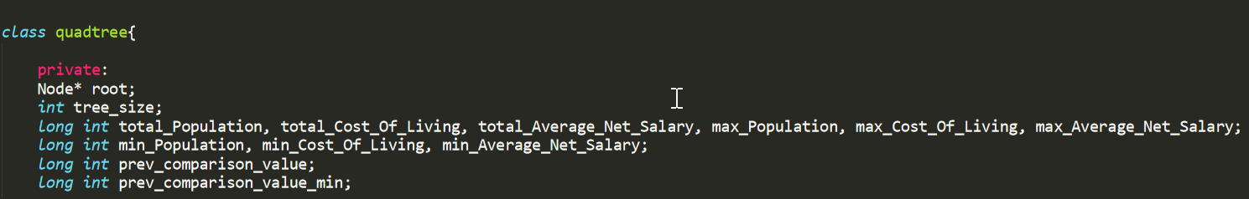  
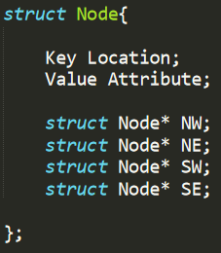

# For each class, what are your design decisions regarding constructors?

* 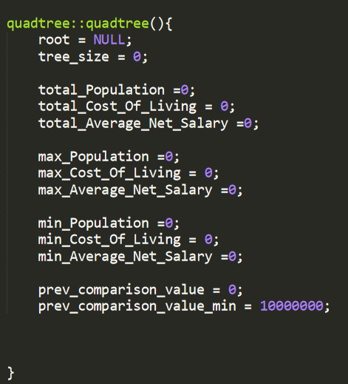initializing the root value to NULL
* Other values, the initial value is 0
* For comparing for the minimum value, the initial value is maximum, that’s why it is 10000000

# For each class, what are your design decisions regarding destructors?

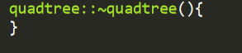

# If It is expected that your implementation has asymptotic upper/tight bound, you should also describe how you have achieved this (or better) runtime in your implementation

Worst-Case Running time for each method of concern

|  |  |
| --- | --- |
| **Function** | **Worst-case Running time** |
| i | O(1) |
| s | O(log(n))- balanced tree height |
| q_max | O(log(n))- balanced tree height |
| q_min | O(log(n))- balanced tree height |
| q_total | O(log(n))- balanced tree height |
| Print | O(log(n))- balanced tree height |
| Clear | O(n) – deleting the pointers |
| Size | O(n)- balanced tree |

# 